Shenyang Aerospace University

Project Design Report

Project Category：Data Structure Project
Project Title：Merging two integer
sequences

College: College of Computer Science
Major: Computer Science and Technology
Class: 1751520107
Student ID: 175152010702
Student Name: Dhiraj Bariyait (丁荣)
Supervisor: Peter Ding
Date: 30th Dec 2020



Contents
Problem Specification 1
Program Design 2
Test Plan and TestCases 5
Sample Execution 6
Analysis and Conclusions 7
References 7
Feedback 7
Appendix A: Source Code 8

Problem Specification

Using linked list as a data structure of two integer sequences A and B whose elements are aligned in ascending order, then merge A and B together and keep A still aligned in ascending order.

C language is required to be the programming language in this project. According to the requirement, linked list data structure is needed to accomplish this project.

Program Design
According to the project requirements, there is one key function to run the program.
The key function is “merge()”. This key function will detect linked lists that have been
created and merge it by moving the pointer to the nodes one by one to create one big
list. The flow chart of “merge()” will be shown in Figure 1.

- Variable Introduction :

First, there are 2 pointers for the head of each lists, head1 and head2. These pointers
must stay at head of the lists, so another pointer must be needed to run this function.
Therefore, temp1 and temp2 are created to help the input process in each first and
second list. Then there are holder1 and holder2. These pointers are made to store the
address of the next node of each linked lists and being set as NULL because the lists
are still empty.

Start

struct node *temp1 = head1;
struct node *temp2 = head2;
struct node *holder1 = NULL;
struct node *holder2 = NULL;

No
temp1 and temp2 are not empty

Yes

holder1 = temp1->next;
temp1->next = temp2;

holder1 is not empty
No

Yes

temp1 = holder1;
temp2= holder2;

End

Figure 1 : Merge Function

Start

LinkList La;
LinkList Lb;
CreateList(La,3);

head1=La;

CreateList(Lb,3);

Head2=Lb;

merge()

print(head1);

End

Fig 2 : Main Function

Test Plan and TestCases
According to the input given, which is creating two sorted linked lists, this program outcome is expected to be the list that has been merged and sorted in ascending order.
Table 1 A Sample of test case
Test Case Number | Input Values | Expected output
1 | A (List 1) : 1 3 5  B(List 2) : 2 4 6 | New List :  1 2 3 4 5 6
2 | A(List 1) : 5 6 8 9  B(List 2) : - | Error

Sample Execution
Paste one screen shot of the execution window of your running program here.

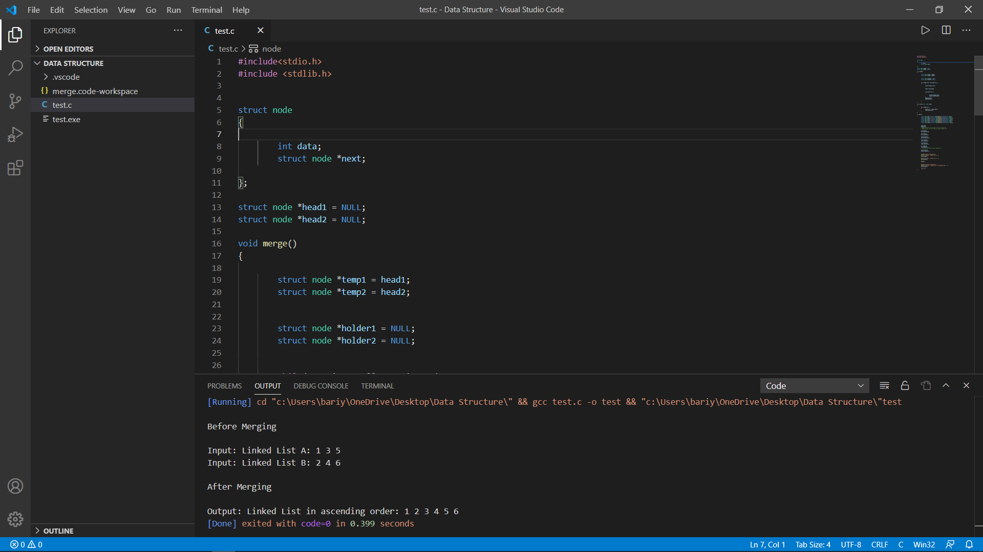

Analysis and Conclusions

This project objective is to create two sorted linked lists and merge it without ruining the order of the elements of the list after merged. Linked list is more efficient than array list because the memory space is not limited, so that there is a possibility to add more elements without concerning the memory space of the list. This report has shown that the project objective has been completed, but there are still some flaws in this project. This program still needs improvement, for example, merge two unsorted lists and sort it in ascending order or removing duplicates when merging the lists. Overall, this program is successful since the program can be run smoothly without any problem.

References
List ALL of the references you used in the project. This includes any help you
received from any other sources other than yourself, lab instructors, your text
book, and course professor.
[1]https://stackoverflow.com/questions/5958169/how-to-merge-two-sorted-arrays-into-a-sorted-array
[2] https://teknosrc.com/data-structures-in-c-linked-list-20-programs/
[3] E Balagurusamy , Programming in ANSCI C , 5th Edition, 2011/10/01.

Feedback
Since linked list is required in this project, it needs extra effort and hardworking to finish because linked list is more complicated than array. In the other words, this project is quite challenging in a good way because it taught more knowledge about data structure and giving a real experience about both data structure and C programming.

Appendix A: Source Code
This section should contain a printed copy of your program, complete with all necessary documentation. Be sure your comments accurately describe what is going on in the code.

#include<stdio.h>

#include<stdlib.h>

//Linked List 1: one->three->five->seven
//Head of Linked List 1 is head1
//Linked List 2: two->four->six
//Head of Linked List 2 is head2

struct node
{
//Structure named node to store integer in variable data and a pointer variable which can store address location of next node

int data;
struct node *next;

};

struct node *head1 = NULL;
struct node *head2 = NULL;

void merge()
{
//Function to merge the two input linked list

struct node *temp1 = head1;
struct node *temp2 = head2;

//Use a new pointer variable temp1 and temp2

struct node *holder1 = NULL;
struct node *holder2 = NULL;

// pointer variables to store the address of next node of the two input linked list

while(temp1!=NULL && temp2!=NULL)
{
//Executes until both temp1 and temp2 are not NULL

holder1=temp1->next;
//Storing the address of next node of first linked list

temp1->next=temp2;
//Making the first node of first linked list point to first node of second linked list

if(holder1!=NULL)
{
//Making the first node of second linked list point to second node of first linked list

holder2=temp2->next;
temp2->next=holder1;
}
temp1=holder1;
temp2=holder2;
//Updating the address location of two pointer variables temp1 and temp2

}
}

void print(struct node *temp)
{
//This funtion is used to print the data in each of the node in the linked list

while(temp!=NULL)
{
printf("%d ",temp->data);
temp=temp->next;
}
}

int main()
{
struct node *one = (struct node*)malloc(sizeof(struct node));
struct node *two = (struct node*)malloc(sizeof(struct node));
struct node *three = (struct node*)malloc(sizeof(struct node));
struct node *four = (struct node*)malloc(sizeof(struct node));
struct node *five = (struct node*)malloc(sizeof(struct node));
struct node *six = (struct node*)malloc(sizeof(struct node));
struct node *seven = (struct node*)malloc(sizeof(struct node));

head1=one;
head2=two;
//head1 points to first node of first linked list
//head2 points to first node of second linked list

one->data=1;
one->next=three;

two->data=2;
two->next=four;

three->data=3;
three->next=five;

four->data=4;
four->next=six;

five->data=5;
five->next=NULL;

six->data=6;
six->next=NULL;
//Last node of second input linked list

seven->data=7;
seven->next=NULL;

//Linked List 1: one->three->five->seven
//Head of Linked List 1 is head1
//Linked List 2: two->four->six
//Head of Linked List 2 is head2

printf("\nBefore Merging\n");
printf("\nInput: Linked List A: ");
print(head1);

printf("\nInput: Linked List B: ");
print(head2);

merge();

//Merging the two linked list into single linked list

printf("\n\nAfter Merging\n");
printf("\nOutput: Linked List in ascending order: ");
print(head1);

return 0;
}

